FlexBox :

- Flexbox is a way to arrange items into rows or columns.
- Some of these properties belong on the flex container, while some go on the flex items.
- Use display:flex; => it will create all the children of flex-container as flex items.
- A flex container is any element that has display: flex on it. A flex item is any element that lives directly inside of a flex container.
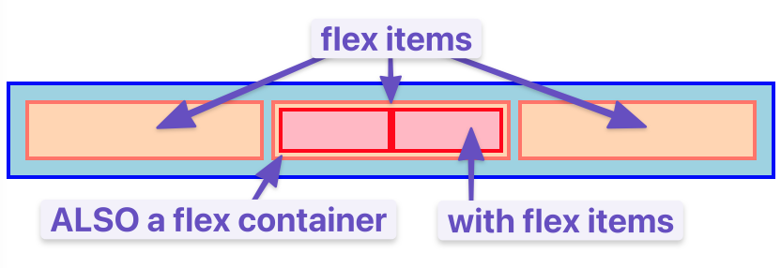
- any element can be both a flex containeranda flex item i.e, can also put display: flex on a flex item and then use flexbox to arrange its children.
- flexbox gives us complete control over the alignment, direction, order, and size of our boxes.

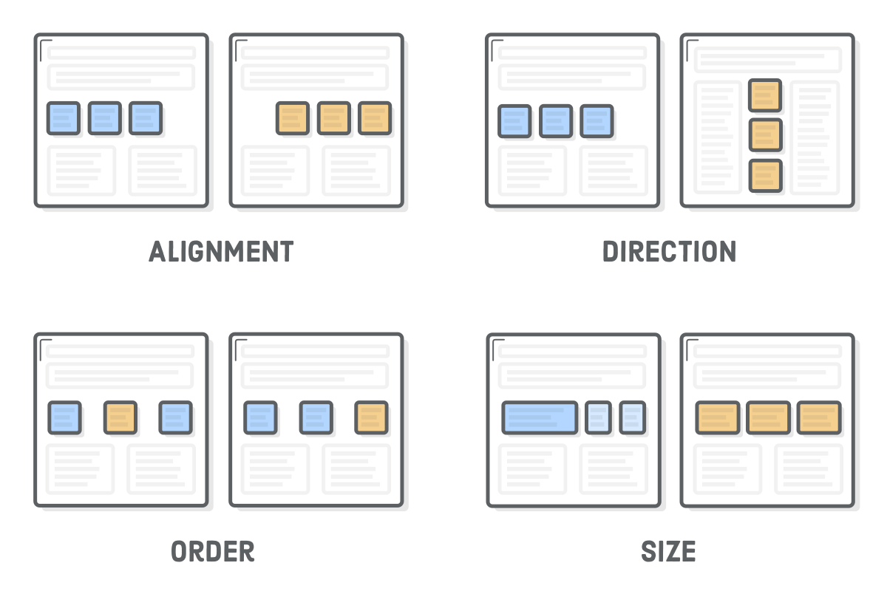

Aligning a flex item (Horizontally):

- justify-content: center; => puts all the flex-items in the center horizontally. This propoerty is added in the flex container.
- This is same as margin: 0 auto trick, with the difference that we apply margin trick directly to items but we position flex-items through flex-container.

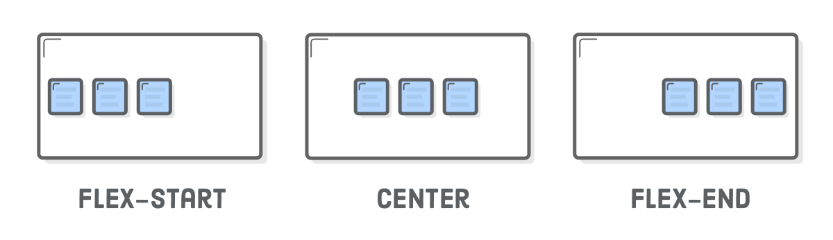

- Justify-content has 2 more attributes => space-around and space-between

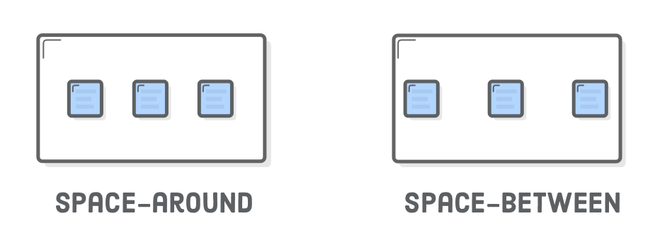
Grouping flex items :

- Flex containers only know how to position elements that are one level deep (i.e., their child elements).
- Wrapping a bunch of items in an extra <div> results in a totally different web page. In below e.g, we wrapped last 2 ele with another div.

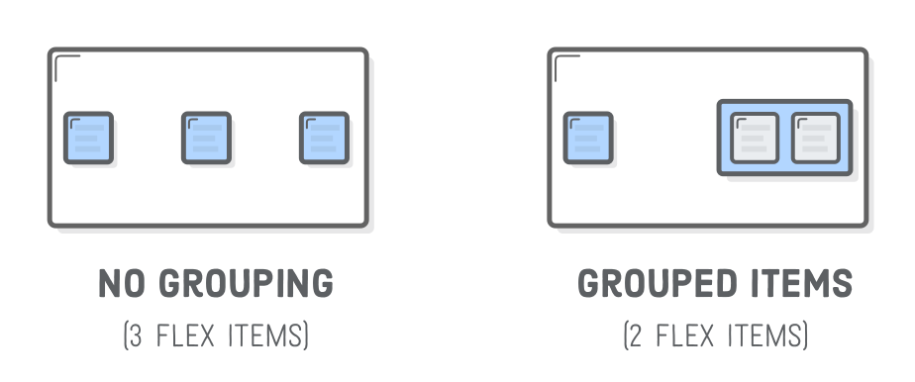

Cross-axis (vertical) alignment :

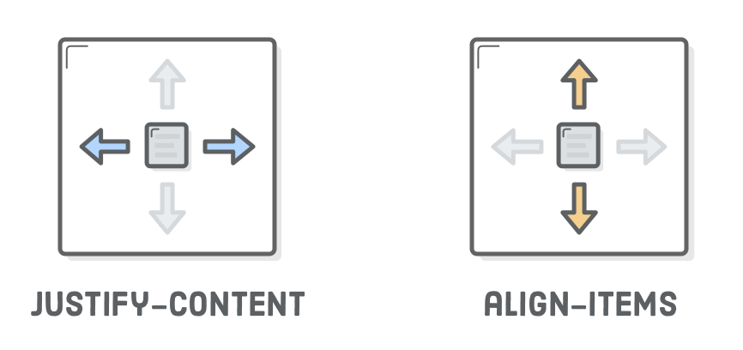

- The available options for align-items is similar to justify-content:
- center
- flex-start (top)
- flex-end (bottom)
- stretch
- baseline

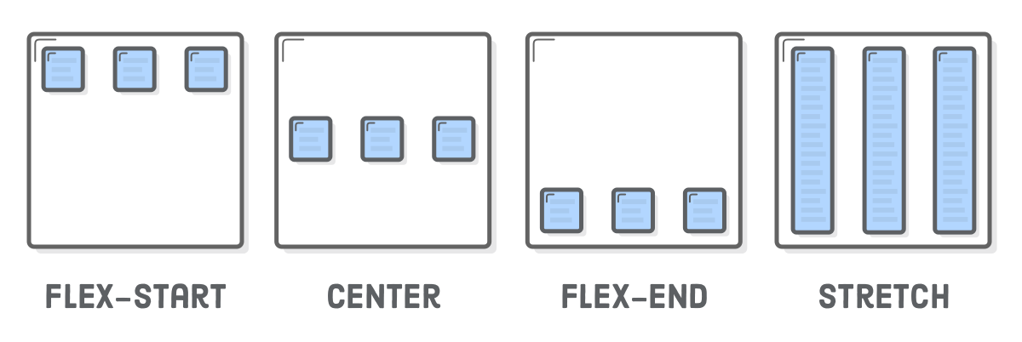

Wrapping Flex items:

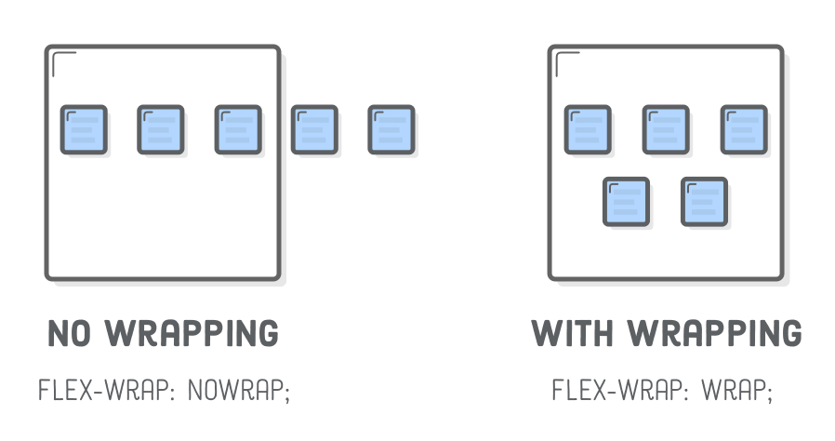
- Now, To create a grid, we need the flex-wrap property.

- <div class='photo-grid-item'>
<img src='images/four.svg'/>
</div>
<div class='photo-grid-item last-item'>
<img src='images/five.svg'/>
</div>
By default, they flow off the edge of the page:
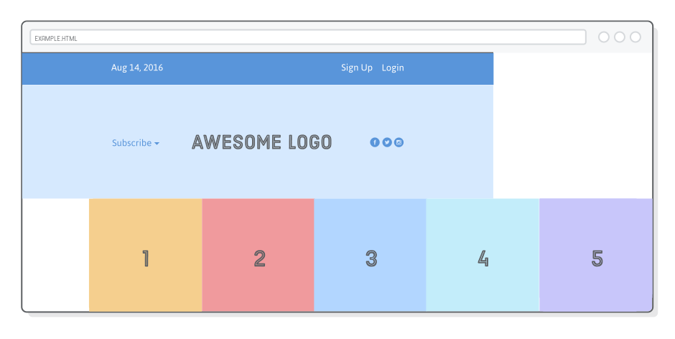

If you’re trying to build a hero banner that lets the user horizontally scroll through a bunch of photos, this might be desired behavior, but that’s not what we want. Adding the following flex-wrap property forces items that don’t fit to get bumped down to the next row:

.photo-grid {
/* ... */
flex-wrap: wrap;
}

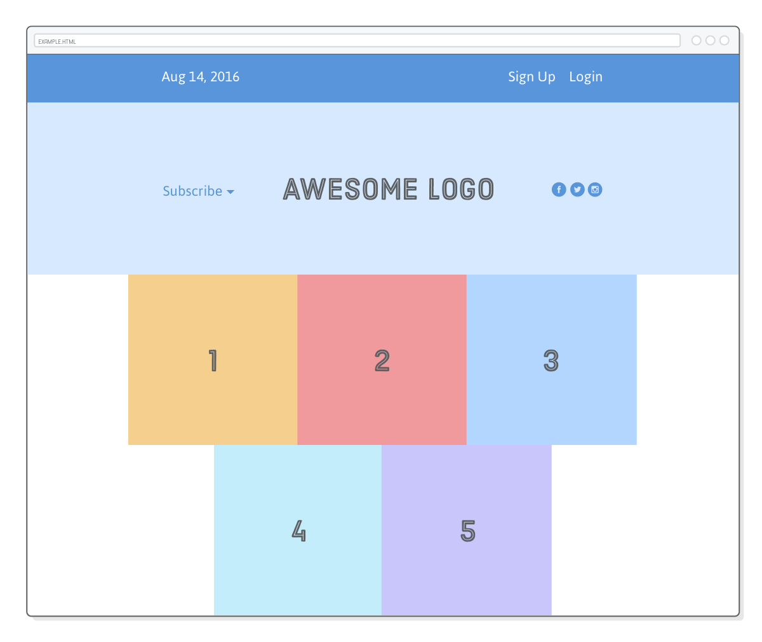

Flex container direction:

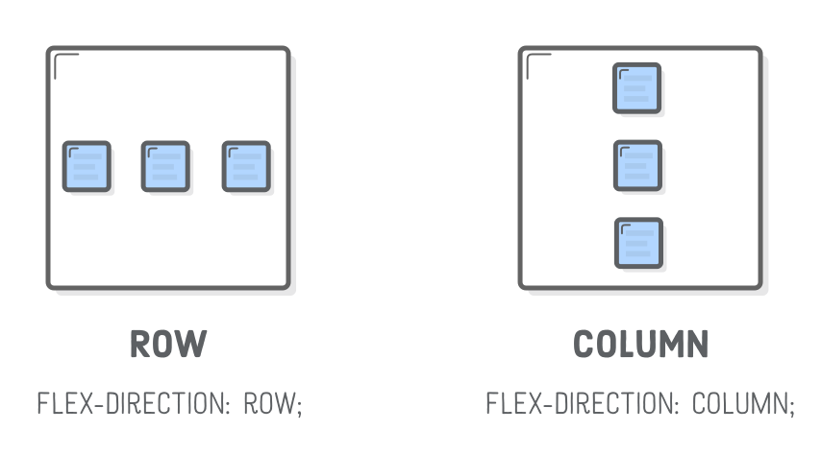
  - “Direction” refers to whether a container renders its items horizontally or vertically.

  - Useful in bulding responsive designs when we do mobile pages as a lot of things will go vertically
  - e.g, flex-direction: column;
  - NOTE => WHEN WE CHANGE THE FLEX DIRECTION WE ALSO INVERT THE justify-content AND align-items PROPERTIES.

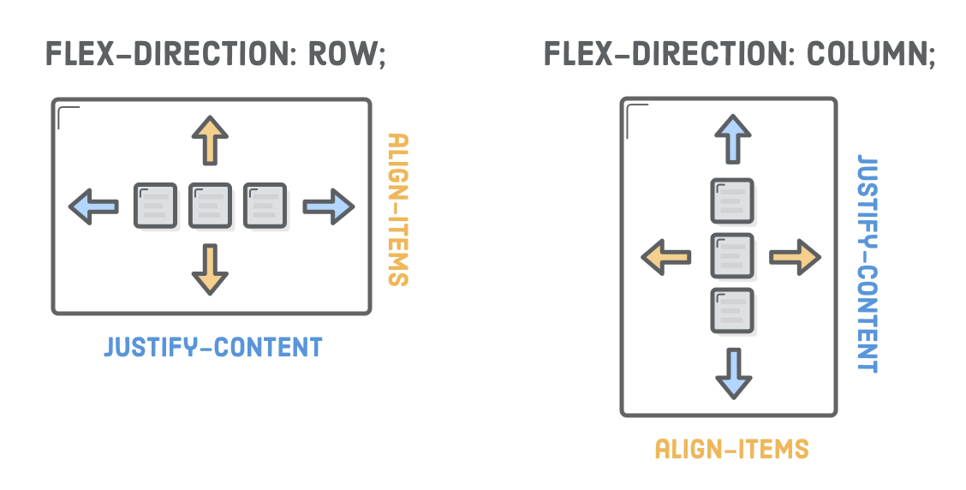

Flex container ORDER:

- flex-direction property also offers you control over the order in which items appear via the row-reverse and column-reverse properties.
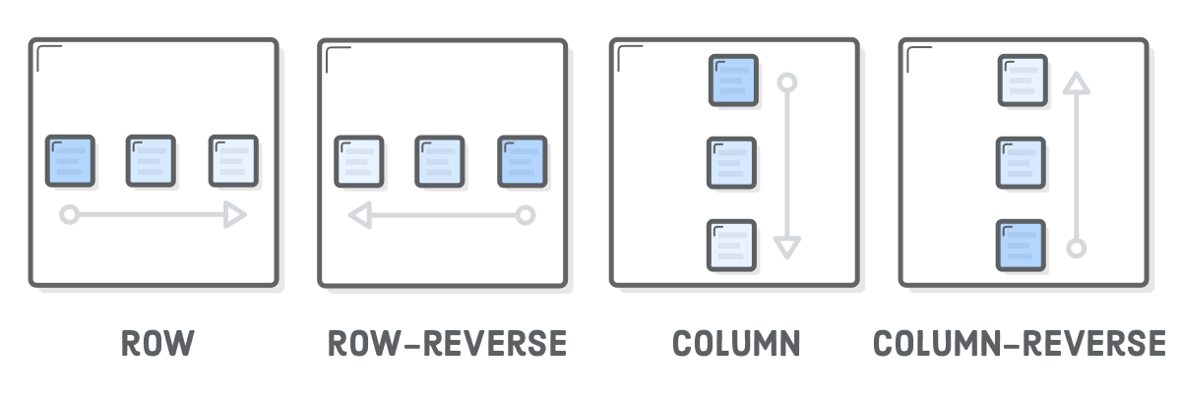

Flex Item ORDER:

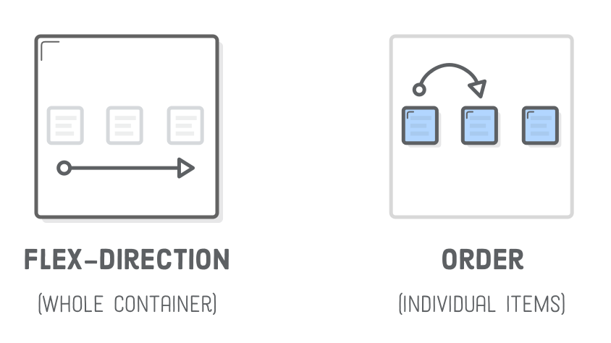

- This entire chapter has been about positioning flex items through their parent containers, but it’s also possible to manipulate individual items.
- Adding an order property to a flex item defines its order in the container without affecting surrounding items. Its default value is 0.
- and increasing or decreasing it from there moves the item to the right or left, respectively.
- This can be used, for example, to swap order of the .first-item and .last-item elements in our grid.
- .photo-grid {

flex-direction: row;
align-items: center;
}

.first-item {
order: 1;
}

.last-item {
order: -1;
}

Flex Item Alignment:

We can do the same thing with vertical alignment. What if we want that Subscribe link and those social icons to go at the bottom of the header instead of the center? Align them individually! This is where the align-self property comes in. Adding this to a flex item overrides the align-items value from its container:
.social,
.subscribe {
align-self: flex-end;
margin-bottom: 20px;
}
This should send them to the bottom of the .header. Note that margins (padding, too) work just like you’d expect.
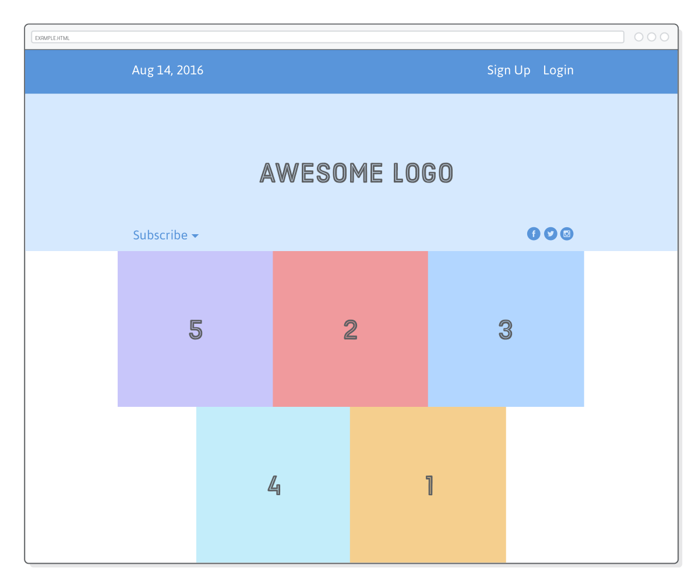

You can align elements in other ways using the same values as the align-items property, listed below for convenience.
- center
- flex-start (top)
- flex-end (bottom)
- stretch
- baseline

Flexible Items:

- All our examples have revolved around items with fixed- or content-defined-widths. This has let us focus on the positioning aspects of flexbox, but it also means we’ve been ignoring its eponymous “flexible box” nature. Flex items are flexible: they can shrink and stretch to match the width of their containers.

- The flex property defines the width of individual items in a flex container. Or, more accurately, it allows them to have flexible widths. It works as a weight that tells the flex container how to distribute extra space to each item. For example, an item with a flex value of 2 will grow twice as fast as items with the default value of 1

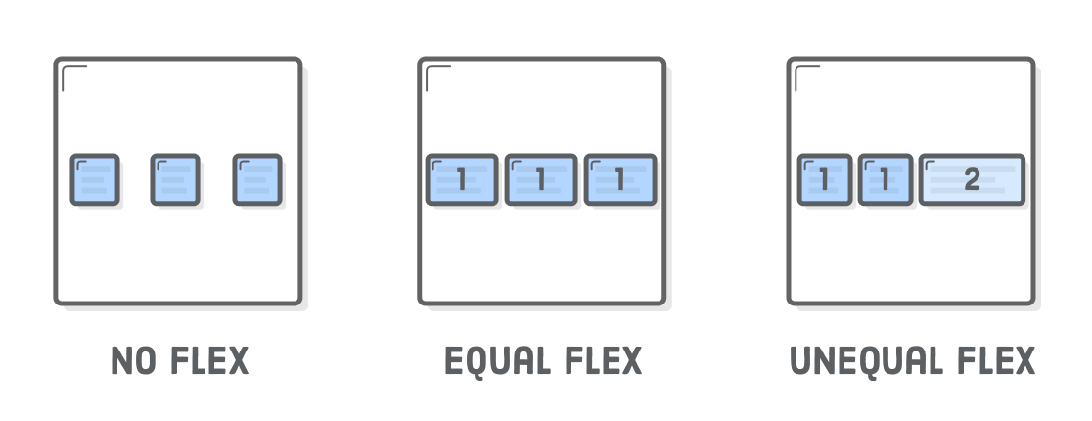

- .footer {
display: flex;
justify-content: space-between;
}

.footer-item {
border: 1px solid #fff;
background-color: #D6E9FE;
height: 200px;
flex: 1;
}
That flex: 1; line tells the items to stretch to match the width of .footer.
- Since they all have the same weight, they’ll stretch equally:
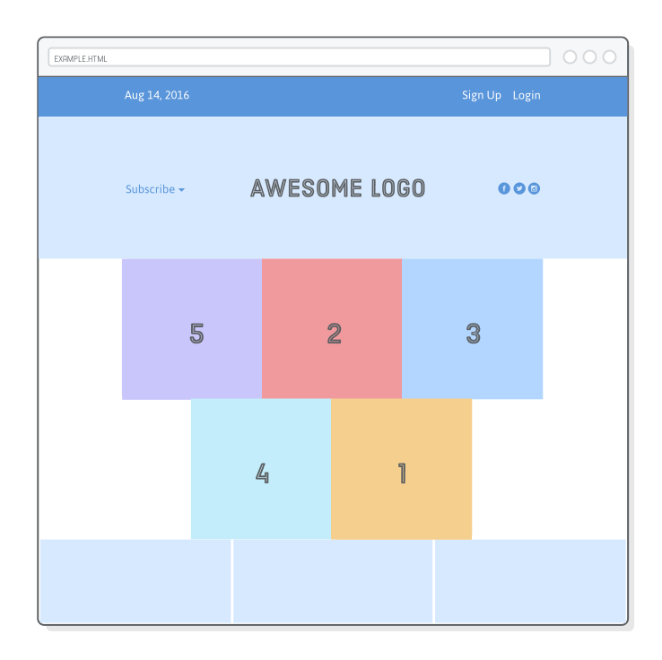

Increasing the weight of one of the items makes it grow faster than the others. For example, we can make the third item grow twice as fast as the other two with the following rule:
.footer-three {
flex: 2;
}
Compare this to the justify-content property, which distributes extra space between items. This is similar, but now we’re distributing that space into the items themselves. The result is full control over how flex items fit into their containers.

static item widths:

We can even mix-and-match flexible boxes with fixed-width ones. flex: initial falls back to the item’s explicit width property. This lets us combine static and flexible boxes in complex ways.
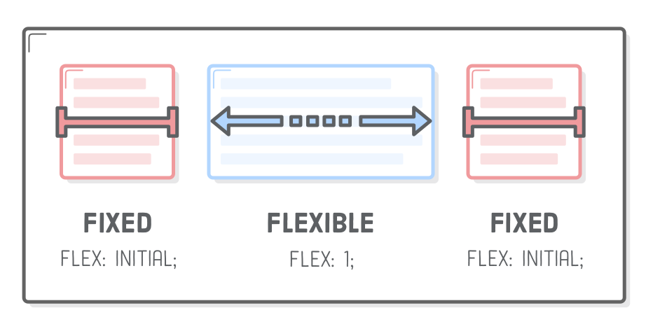

We’re going to make our footer behave like the above diagram. The center item is flexible, but the ones on either side are always the same size. All we need to do is add the following rule to our stylesheet:
.footer-one,
.footer-three {
background-color: #5995DA;
flex: initial;
width: 300px;
}
Without that flex: initial; line, the flex: 1; declaration would be inherited from the .footer-item rule, causing the width properties to be ignored. initial fixes this, and we get a flexible layout that also contains fixed-width items. When you resize the browser window, you’ll see that only the middle box in the footer gets resized.
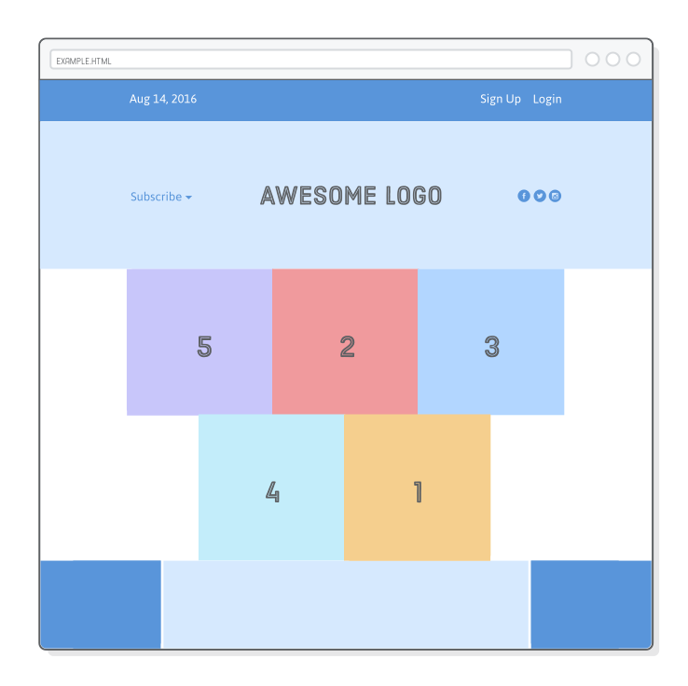

This is a pretty common layout, and not just in footers, either. For instance, many websites have a fixed-width sidebar (or multiple sidebars) and a flexible content block containing the main text of the page. This is basically a taller version of the footer we just created.

Flex items and auto-margins:s
Auto-margins in flexbox are special. They can be used as an alternative to an extra <div> when trying to align a group of items to the left/right of a container. Think of auto-margins as a “divider” for flex items in the same container.
Let’s take a look by flattening our items in .menu so that it matches the following:
<div class='menu-container'>
<div class='menu'>
<div class='date'>Aug 14, 2016</div>
<div class='signup'>Sign Up</div>
<div class='login'>Login</div>
</div>
</div>
Reloading the page should make the items spread out equally through our menu, just like at the beginning of the chapter. We can replicate the desired layout by sticking an auto-margin between the items we want to separate, like so:
.signup {
margin-left: auto;
}
Auto-margins eat up all the extra space in a flex container, so instead of distributing items equally, this moves the .signup and any following items (.login) to the right side of the container. This will give you the exact same layout we had before, but without that extra nested <div> to group them. Sometimes, it’s nice to keep your HTML flatter.

